**Module 28: Theory Mid Term Exam**

1. Calculate the time complexity of the following code snippets.

|  |  |
| --- | --- |
| (a) | for(int i =0; i<n; i=i*2){  p++;  }  for(int j=1; j<p; j=j*2){  printf("hello");  } |
| (b) | for(int i =1; i*i<n; i++){  printf("hello");  } |
| (c) | for(int i =0; i<n; i=i*2)  {  for(int j=1; j<i; j++){  printf("hello");  }  } |

1. Write down all the steps of **Counting Sort** on the Following Array.

|  |  |  |  |  |  |  |  |  |
| --- | --- | --- | --- | --- | --- | --- | --- | --- |
| Index | 0 | 1 | 2 | 3 | 4 | 5 | 6 | 7 |
| Value | 3 | 3 | 1 | 7 | 7 | 4 | 4 | 5 |

1. Find ‘4’ in the following array using Binary Search and show the steps. Draw the Binary Search Tree for the given Array using the Binary Search technique.

|  |  |  |  |  |  |  |  |  |  |  |
| --- | --- | --- | --- | --- | --- | --- | --- | --- | --- | --- |
| Index | 0 | 1 | 2 | 3 | 4 | 5 | 6 | 7 | 8 | 9 |
| Value | 1 | 2 | 4 | 9 | 12 | 14 | 16 | 21 | 32 | 35 |

1. Assume a 2D array is declared as **int arr[70][65]**. The value of the base address of the array is **arr[0][0] = 1230**. Find out the location of **arr[3][18]. (**An Integer is a word addressable (4 bytes) datatype)
2. Answer the following questions for the doubly linked list as shown below, where p = 12 , q = p+4, r = p+q, s = r-3, t = r+s.

a) head −> next −>next-> value = ?

b) last −> prev −> next->value = ?

c) temp −> prev −> prev −> prev= ?

d) temp −> next−> prev −>prev->value = ?

e) last −> prev −> prev −>next-> value = ?

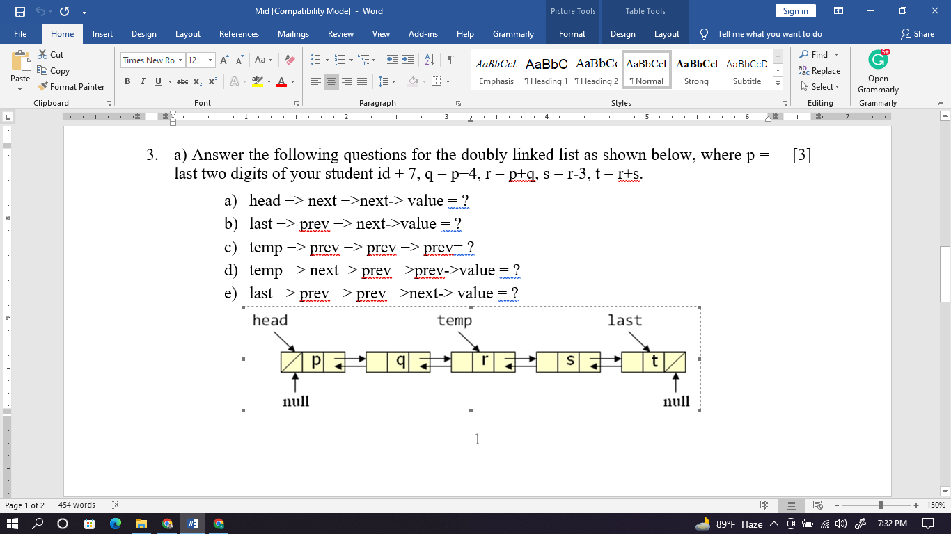

1. Assume that you are given a single linked list as shown below. Write the statements to perform the following:

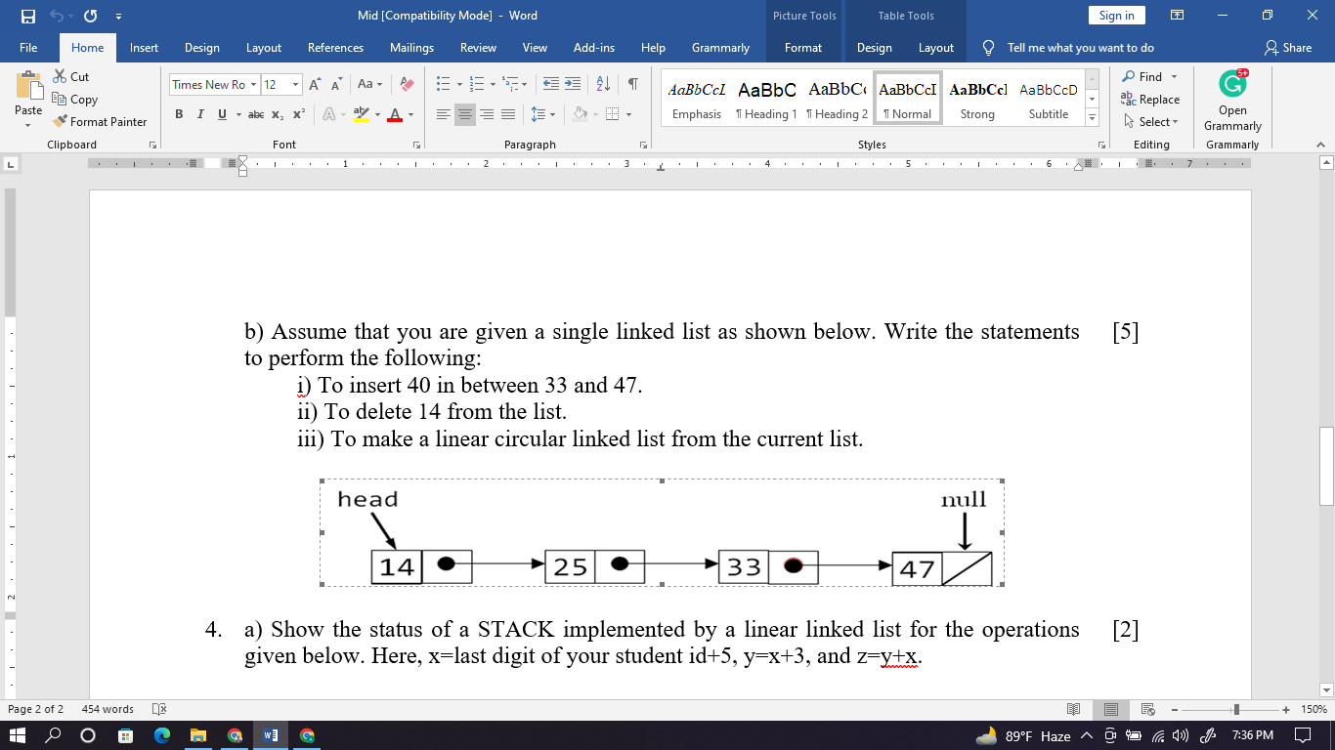

i) To insert 40 in between 33 and 47.

ii) To delete 14 from the list.

iii) To make a linear circular linked list from the current list.

1. Write an algorithm to display the data stored in a doubly linked list in reverse order. Assume only the head pointer is given for the linked list.
2. Show the status of a STACK implemented by a linear linked list for the operations given below. Here, x= Last day of your birthday + 5, y=x+3, and z=y+x.

Push(x+y), Push(y+z), Pop(), Push(y*z), Push(x*y), Pop(), Pop()

1. Show the effect of each of the statements given in the following code using a Stack.

|  |
| --- |
| #include<stdio.h>  #include<string.h>  int top=-1;  char Stack[4]={‘\0’};  int main()  {  char Str1[4]={‘\0’};  char Str2[4]={‘\0’};  int i;  strcpy(Str1, “CSE”);  for(i=0; i<3; ++i){  Push(Str1[i]);  }  for(i=0; i<3; ++i){  Str2[i]=Pop();  }  printf(“%s”, Str2);  return 0;  }    void Push(char x){  Stack[++top]=x;  return;  }  char Pop(void){  return Stack[top--];} |

1. What are the merits of implementing a QUEUE using Array in a circular fashion? How do you check the underflow and overflow in the QUEUE implemented circularly?
2. Show the status of a QUEUE for the following operations, where the QUEUE is implemented by an array of size, m=3. Here, Enqueue and Dequeue mean insert and delete respectively, and x=9,, y=x+3, z=x+y, and p=y+z.

Enqueue(z), Enqueue(p), Dequeue(), Enqueue(y), Enqueue(z)

1. Generate a psuedocode for solving the following problems within a time complexity of O(n^2)

Delete all of the consecutive elements from a Linear Linked List whose sum is equal to (Zero).

|  |  |  |
| --- | --- | --- |
| Input | Output | Explanation |
| 8  6 -6 8 4 -12 9 8 -8 | 9 | 6-6 = 0  8+4-12 =0  8-8 =0  Thus, all of these numbers from the list is eliminated |
| 11  4 6 -10 8 9 10 -19 10 -18 20 25 | 20->25 | 4+6-10=0  8+10-18=0  9+10 = -19  Thus, all of these numbers from the list is eliminated |